ChartReview FAQ

What is ChartReview?

ChartReview is a multi-project, multi-user web application that is hosted on a VA machine called vhacdwdwhweb11 within the VINCI firewall.  You access it by logging into vinci and opening a FireFox browser that has been configured for Windows Integrated Authentication to access the server.  You are added to ChartReview as a user and you are able to create projects yourself.  As a user, you will only see the projects and data that you are included on and that you have database permissions to see.  A project definition includes a JDBC url which tells ChartReview the location of your project database.  A mapping is created in ChartReview between the database tables and the view of that data in the user interface using a SQL query.  Many projects define views in the db with all of the filters (cohort patients only, time window, only required fields, etc.) and indexes pre-applied so that the query to map data into ChartReview is very simple and fast.  The mappings are called clinical element definitions and when viewed in the ChartReview UI, they are called clinical element views.  A chart is made up of N number of project coordinator defined clinical elements and the set of clinical elements can be different for each annotation workflow that is created.

**VINCI**

What database permissions are needed?

Both the project coordinator and the annotators will need read/write privileges to the database.  Annotations as well as some project metadata are stored in the project database and ChartReview will try to create and write to these tables on use.

Would the Chart Reviewer instance be installed on our dev server, or would we be running it remotely?

Remotely

Would we be able to do some small trial versions on our own just to make sure that we have the data display and the annotation functionality in the way that best fits our project needs.

Yes

Would we need to come to your group every time we set up a new project?

No

What software do I need to put on my RDS or development VINCI machine to be able to access ChartReview?

The only software needed to access ChartReview from within VINCI is a FireFox browser with Integrated Authentication enabled (there is a plugin on the Software drive under FireFox), allowing access to vhacdwdwhweb11.vinci.med.va.gov and vhacdwdwhweb11.

What are the first steps in preparing to use ChartReview in VINCI?

The first steps in using ChartReview are

1) Make sure you have a project database in VINCI

2) Make sure that you understand how to query that database to find the views of the information that you would want to see in ChartReview as you do an annotation workflow for your project.  You might want to have your data person available for the initial meetings and setup walkthroughs with the VINCI services team?  Basically, you need to have an SQL query defined for each view of the patient data that you want to see in ChartReview.  With those queries defined (some projects, in fact, have created database views with filters applied, indexes, etc), the team can show you how to map them into ChartReview, but they will not likely understand your project tables and the information in them enough to do that part of the definition.

How do I get my database ready for use in ChartReview in VINCI?

You need to create queries that will be used to map the database data into ChartReview views. For example, you may want to create queries for data such as:

1. Query/View of patients in cohort
2. Query/View of TIUNotes joined with patient
3. Query/View of LAB joined with patient
4. Query/View of Pharm joined with patient
5. Query/View of Radiology joined with patient

Many studies that have used ChartReview have a cohort table with patient ids in it.  Also, in many cases, they have created db views for each of the patient, visit, lab, pharm, radiology tables, joined with the patient view, having applied all date range filtering, etc. on the view, and indexing the views for speed of query.  Depending upon the size of the visit, lab, pharm, and radiology tables, a query against a filtered view would be much more performant than a query against the full tables using a where clause from within the application. You may either rename database fields in your query/view, or you may rename then in the ChartReview mapping to more user-friendly or annotation task specific terms.

Are there plans to include any graphical views, for example graphing laboratory data?

We have lab graphing captured in our backlog of features, but that feature does not have imminent priority.  If it is a really desirable feature for your team, we can track importance and possibly escalate the priority.  Let us know the priority of that feature compared to the priority of other features you may also want.

How do I log into VINCI, a VINCI temporary, virtual RDS machine, or a VINCI development machine?

VINCI:

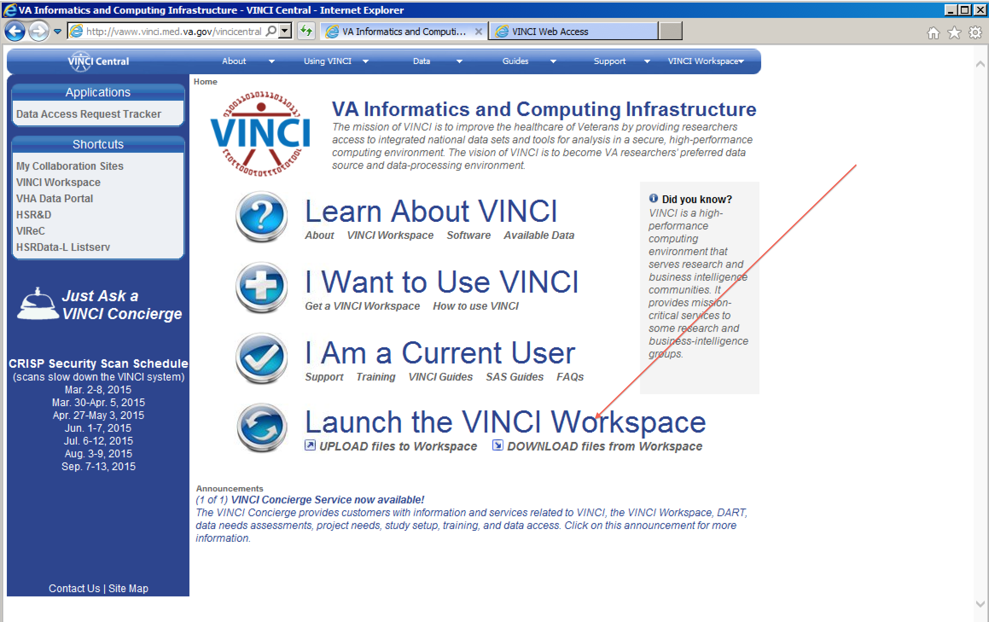

RDS:

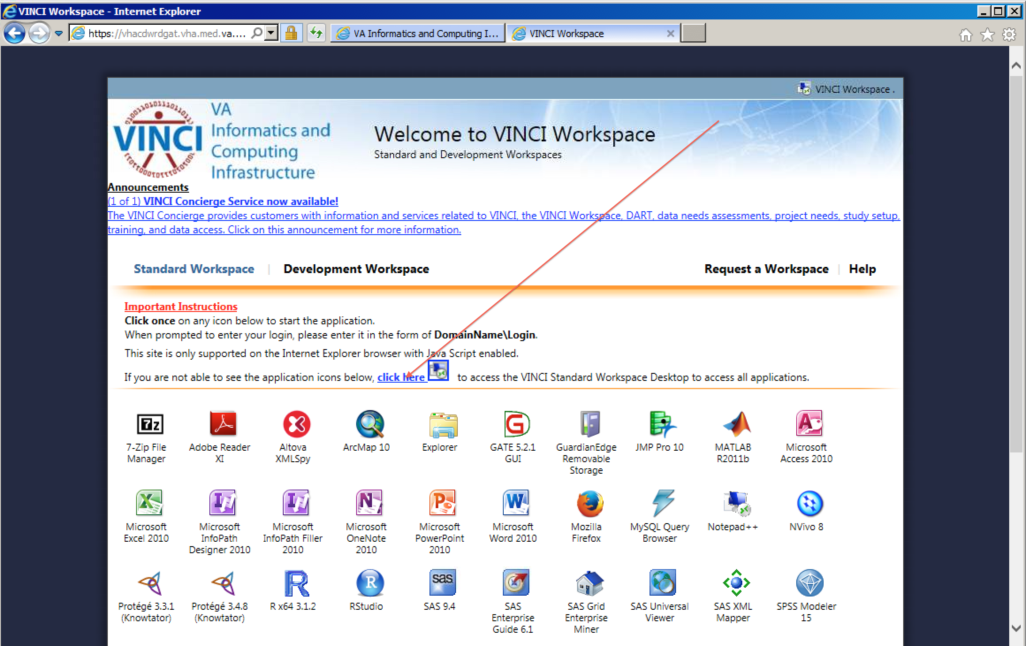

DEV

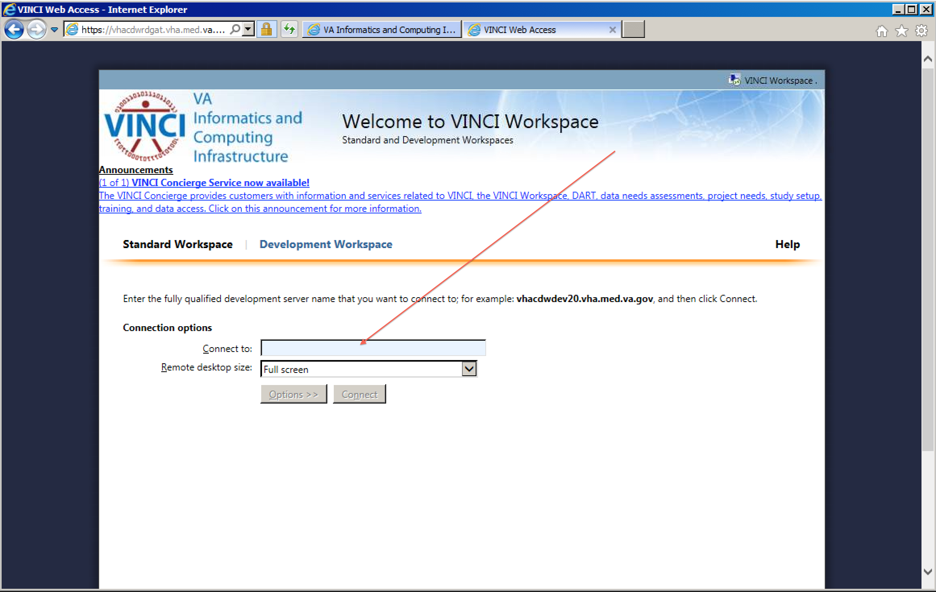

How do I enable Integrated Authentication (Single sign-on, SSO) in the Firefox browser?

1. Install FF on your VINCI RDS or DEV machine from the Software drive  \\vhacdwfpcfs01\data\Software\Site Licensed\Firefox
2. Right click on the FF header and enable the Menu bar (to see the Tools Menu)
3. Install the FF Integrated Authentication plugin from Sofware drive \\vhacdwfpcfs01\data\Software\SiteLicensed\Firefox\plugins
4. Through Tools->Integrated Authentication Sites, add vhacdwdwhweb11 and vhacdwdwhweb11.vinci.med.va.gov to the list of Integrated-auth-enabled sites.
5. If you have it configured right, when you hit <http://vhacdwdwhweb11:8080/chart-review> you should not get the login screen.  It should just log you in to the home page with your login id in the upper right.

What do I do once I have a project on the VINCI hosted ChartReview?

 One thing that will be more difficult in setting up your project on the hosted machine is that you cannot currently see any server-side errors because you cannot see the log files.  We will be glad to look into the logs at anytime for you.  We have plans to return more server errors related to bad SQL queries or database connection issues that you may have misconfigured in your project.  Projects have found it useful to try all of the queries that they build in MS SQL Workbench first.

Here is a suggested todo list:

1. Admin->Project->Actions->Create Siman Tables (creates the CR metadata tables in your database)
2. Admin->Clinical Element Configurations->Create Clinical Element (queries to map the db to your CR UI Views)
3. Admin->Schemas->Create Schema (annotation schema)
4. Admin->Project->Documents->Upload  (annotation guideline)
5. Admin->Project->Processes->Add Process (the workflow tasks)

Under what license is ChartReview released?

Per the VA request, we have released under the Apache license:

<https://github.com/department-of-veterans-affairs/ChartReview/blob/master/LICENSE.txt>

We have released the code as open source, so we believe we are covered with respect to the Sencha licensing statement below.  If there are disagreements or further needs are present, we can escalate this answer/solution within our organization to produce the needed answers and results.

*Sencha Ext JS is made available under Commercial License or the GNU General Public License version 3 (GPLv3). The Commercial License requires the payment of a fee for each Designated User (i.e. developer). If you choose not to pay a fee and use the GPLv3 license, you are generally required to release the source code of any program that you distribute that uses Ext JS. If you choose to pay for a Commercial License, you are not required to disclose your source code.*

**NON-VINCI Deployments**

Is it possible to use SQL Server for the Chart Review specific (not patient data) database, instead of using MySQL? If so, how would I go about doing that?

That is theoretically possible, but we have not tested that.  The connection to the CR metadata database is specified in tomcat\conf\Catalina\localhost\chart-review.xml.  That jdbc string would need to point to a sqlserver db instead of the mysql db.  The database would need to allow login by username/password. Let us know what you are trying to do here and maybe we can escalate the investigation of this type of deployment.

I was unclear if there’s a solution or not for more than one investigator using chart review on the same machine. My understanding from the instruction manual is that because we are setting the LogOn parameter in Tomcat server to a particular user, all users have to use a single user’s credentials to log onto project databases. This obviously causes problems when different investigators have different projects which need access to different databases. Am I misunderstanding the instructions?

You are correct, without a Single Sign On deployment, all projects created in an instance of ChartReview would need to be accessible with the credentials of the person who launched the tomcat instance.  However ChartReview is able to be deployed in a single sign-on environment which allows multiple users to each use their operating system credentials to be automatically logged into ChartReview and to control their access to data at the database level using those credentials. Single Sign-On deployment instructions can be provided upon request, but the instructions will need to be customized for each individual environment by the system administrators of that environment.